Walk 26 Skenfrith Castle Walk
Last walked in November 2017

Description. An 8 km (5 mile) pleasant moderate walk, with excellent views of the hilly countryside.
Start. Parking area in front of Skenfrith Castle. Explorer Map 189. Grid 458202.
Direction from Belmont roundabout (Turn milometer to zero). Take the A49 towards Ross-on-Wye. At 4.5 miles TR and take the 466 to Monmouth. Carry on the 466 thru Wormelow, then thru St Weonards, and at 11.2 miles TR towards Abergavenny. Go thru the hamlet of Broad Oak and at 14.1 miles TR and park at Skenfrith Castle.

1. Skinfrith Castle. Skenfrith Castle is the only low-lying fortress of the three castles of Skenfrith, Grosmont and White Castle, now known as the castles of the Trilateral. We have no early reference as to the foundation of the fortress, though a castle certainly existed here by 1160 when it came into the king’s hands. In 1187 the engineer Ralph Grosmont was instructed by King Henry II to rebuild the castle in stone. However this work proved abortive and Henry II cancelled the building work in 1188 as unnecessary. In 1193, Sheriff William Braose pushed the unfinished castle into rapid service and a prison was later built within the stockade. With your back to the castle TR and walk along the minor road that bends L then R, going past ‘St Bridget’s church, a ‘National School AD1843, ‘The Old Vicarage and the ‘Malthouse before the road crossing over a stream where you TR for Grosmont Castle and walk up a No Thru Road. Continue along this road for a good kilometre as it changes into a stony enclosed track when you go over a cattle grid. At the bottom of the hill near the river at Birch Hill, just before another cattle grid, cross over a stile on your R side and continue in the same direction along an enclosed footpath.

2. Wooden Stile. Continue along the footpath passing a farmhouse on your L to cross a stile and continue along a dirt track going down towards the river. Cross a stile that’s on the R side of a metal gate and go into a field. TL, walk along the L field edge and after 30 paces bare R, a little further on you go along a way marked wooden walkway. Cross a stile, down some steps and along another wooden walkway. At the end of the walkway TR and go across a small concrete bridge over a brook and into F1, continue along the R field edge. Cross a stile/metal gate into F2 and along the R edge. Go over stile/metal gate into F3 and bear slightly away from the field edge to go over stile/metal gate and continue along the R edge of F4, passing Trevonny farm on your R. Cross a stile and two wooden planks into F5, the hedge is on your L. After short distance you hit a farm track, TL, go thru metal gate and continue up the enclosed stony track towards Box Farm.

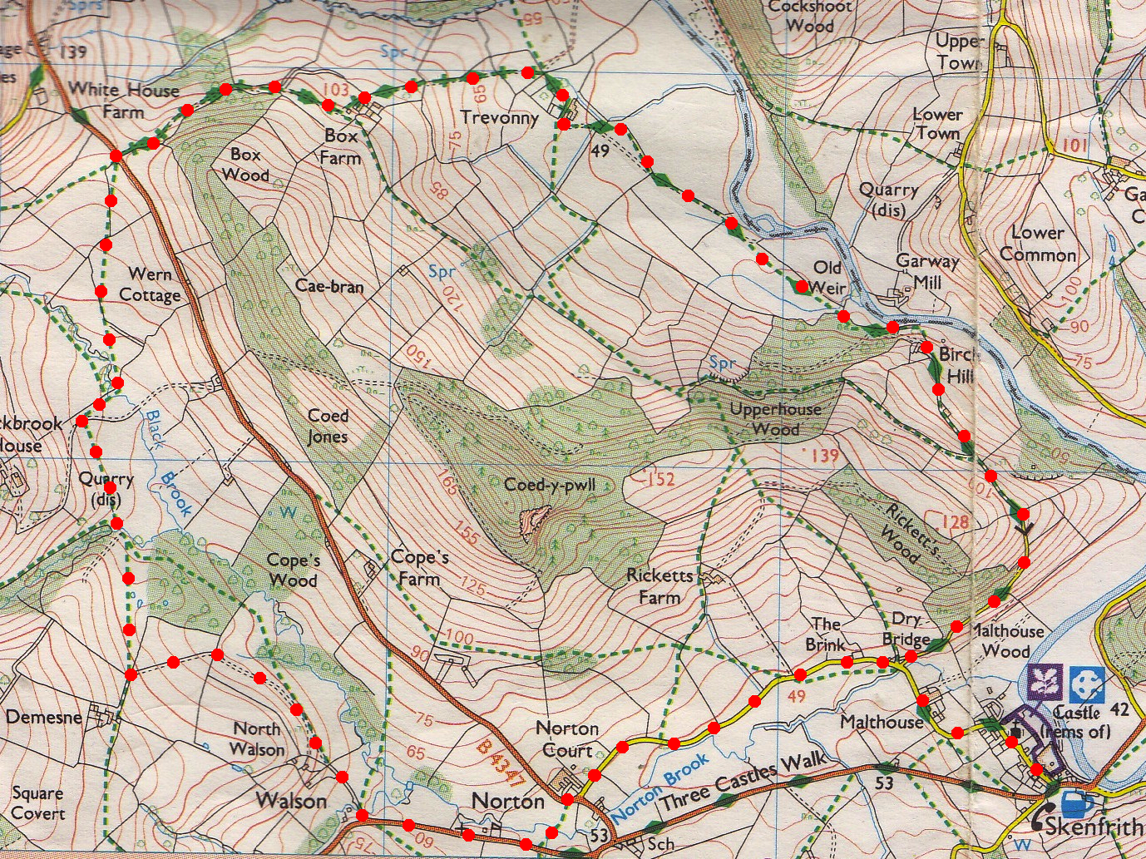
3. Box Farm. Go thru the farmyard and at the end TR, pass the farm house that is on your L and cross over a cattle grid, continue along the farm track/drive to eventually cross another cattle grid and onto the main road. In front of you are two metal gates, go thru the L gate/stile into F6. Bear slightly L and follow the hedge on your R, near the far end of the field and just before reaching two big trees you TR thru a metal gate into F7. Bear L to the far corner and go over a stile. TR, cross a gated wooden footbridge and up some wooden steps. Continue on for a short distance and hit a tarmac drive where you TR. Continue up the drive to cross over a cattle grid, TL and go thru a wooden gate into F8. Go straight across this field, thru a small wooden gate/metal gate, across a brook and up the track that bends to the R. Go straight across this field (F9), heading to the L of the buildings in front of you to go thru the gate in the corner and onto a farm track/drive. TL and proceed down the drive. The drive bends to the R and goes over a cattle grid, it then continues on and goes over another cattle grid before reaching the main road.
3
2
1
4
4. Main Road. TL, walk along the main road and after about 140m you pass Norton Baptist Church(L), after another 200m you TL over a stile by a footpath sign and into a small field. Keep to the brook that’s on your R to cross a gated wooden footbridge over a stream and into F10. Cross the field then a stile/metal gate onto a main road. TR, 30m on you TL and proceed along a narrow single lane road for 1½ km to Skinfrith Castle and the car.

